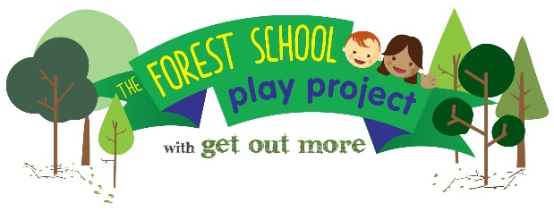

Forest School Level 3 Practitioner Award: 20-24 April and 16-20 November 2020

Wonderful Early years Training Hub, Heaton, Bradford

A free programme for early years workers and parents living or working in the Better Start Bradford area, (Bradford Moor, Bowling and Barkerend and Little Horton). Eligible trainees will be able to apply their training to run forest schools with children aged 0-3 in the Better Start Bradford area. Trainees must attend both training weeks.

Level 3 Course Outline: Lily Horseman of Kindling Play and Training will deliver an accredited course that inspires and excites participants whilst providing all the theory, skills and knowledge necessary to set up and lead a forest school programme. The course guides learners through an enjoyable, supportive learning process with clear, easy to understand teaching materials. The course is taught inside and outside through a mixture of games, practical activities, reflection and creative presentations

Learners are assessed in their learning through the submission of 20 bite sized assessment tasks, completed throughout the course. Some tasks will be completed during the training and some will be written up in between the taught sessions. Participants on the course will need to plan and deliver 6 Forest School sessions with the same group of children.
Target group: This Forest School Level 3 course is aimed at individuals who have a minimum Level 2 qualification in Youth Work, Child Care, Teaching, or relevant experience in working with children. The level 3 qualification equips trainees with the skills and accreditation to lead forest schools. The course has been programmed for early years workers and parents of young children from the Better Start Bradford area.Better Start Bradford postcode checker: https://www.betterstartbradford.org.uk/about-us/our-part-of-bradford/

The Forest School Play Project and Better Start Bradford: This course is part of The Forest School Play Project, a Better Start Bradford project, being delivered by Get Out More over the next 3 years. This programme will offer hundreds of young children and their families in Bowling & Barkerend, Bradford Moor and Little Horton the chance to experience the benefits of nature-based learning through engaging with forest school.

The course is free to trainees and there are only 12 places available, therefore places will be awarded on merit following an application process. Please complete the form on the following pages and return it to Annie Berrington at the above email/postal address by: Friday 14 February 2020

APPLICATION FORM

NAME
EMAIL ADDRESS
PHONE NUMBER

I am applying as: (tick one only)

Parent of child aged 0-3 years, living in the Better Start Bradford area

Early Years worker, working with children aged 0-3 in the Better Start Bradford area

If parent; HOME ADDRESS INC POSTCODE

If Early years worker: NAME AND ADDRESS OF EMPLOYER
POSITION
MAIN RESPONSIBILITIES

It is a requirement of the course that all trainees attend all training days in full

If I am selected for the course, I commit to attending all 10 training days in full

Applicants signature Date

Early Years workers only: Trainees are expected to implement learning from the course within their setting, for the benefit of young children in the Better Start Bradford area.

I agree to support the applicant in implementing learning from the course within our setting

Line Manager’s signature Date

All applicants must complete the following 3 questions. Please give details; answers to each question should be between 100-200 words
Boxes will expand as required.

- 1. Please give details about any past experience you have working within an outdoor environment, including any examples where you have worked with children.

- 2. Why do you wish to do the Level 3 Forest School Practitioner course?

- 3. How will you use this training to improve outcomes for young children in the Better Start Bradford area?

Return the form by email or post to Annie Berrington by 14 February 2020

annie@getoutmorecic.co.uk
Get Out More CIC, AES Orchard, Sunderland St, Keighley, BD21 5LE

