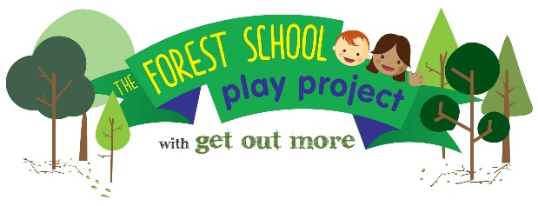

Forest School Level 1 Practitioner award: 23-25 September 2020

Wonderful Early years Training Hub, Heaton, Bradford

A free programme for early years workers and parents living or working in the Better Start Bradford area, (Bradford Moor, Bowling and Barkerend and Little Horton). Eligible trainees will be able to use their skills to benefit children aged 0-3 in the Better Start Bradford area.

Lily Horseman of Kindling Play and Training will introduce basic woodland skills, and individuals will be required to demonstrate a basic knowledge of the flora and fauna in a woodland area. The course will allow participants to look at using the outdoor environment to facilitate different learning styles and to encourage the development of personal skills such as confidence and self-esteem.

Participants will learn how the outdoors can be used to encourage all areas of development, understand factors that affect children’s behaviour and strategies for the outdoor environment. We will also look at how the outdoor environment encourages independence, self-reliance and self-esteem and promotes healthy, balanced social and emotional growth.

Portfolio Completion will take place during the course and be handed in on the last day.
Target group: This course is ideal for those people who are wanting to gain skills for working outdoors with children and young people, those who want to explore Forest Schools within their own setting or those who wish to support a trained Forest Schools practitioner. The course has been programmed for early years workers and parents of young children from the Better Start Bradford area.Better Start Bradford postcode checker: https://www.betterstartbradford.org.uk/about-us/our-part-of-bradford/
The Forest School Play Project and Better Start Bradford: This course is part of The Forest School Play Project, a Better Start Bradford project, being delivered by Get Out More over the next 3 years. This programme will offer hundreds of young children and their families in Bowling & Barkerend, Bradford Moor and Little Horton the chance to experience the benefits of nature-based learning through engaging with forest school.

The course is free to trainees and there are only 10 places available, therefore places will be awarded on merit following an application process. Please complete the form on the following pages and return it to Annie Berrington at the above email/postal address by: Friday 30 April 2020.

APPLICATION FORM

NAME
EMAIL ADDRESS
PHONE NUMBER

I am applying as: (tick one only)

Parent of child aged 0-3 years, living in the Better Start Bradford area

Early Years worker, working with children aged 0-3 in the Better Start Bradford area

If parent; HOME ADDRESS INC POSTCODE

If Early Years worker: NAME AND ADDRESS OF EMPLOYER
POSITION
MAIN RESPONSIBILITIES

It is a requirement of the course that all trainees attend all training days in full

If I am selected for the course, I commit to attending all 3 training days in full

Applicants signature Date

Early Years workers only: Trainees are expected to implement learning from the course within their setting, for the benefit of young children in the Better Start Bradford area.

I agree to support the applicant in implementing learning from the course within our setting

Line Manager’s signature Date

All applicants must complete the following 3 questions. Please give details; answers to each question should be between 100-200 words.
Boxes will expand as required.

- 1. Please give details about any past experience you have working within an outdoor environment, including any examples where you have worked with children.

- 2. Why do you wish to do the Level 3 Forest School Practitioner course?

- 3. How will you use this training to improve outcomes for young children in the Better Start Bradford area?

Return the form by email or post to Annie Berrington by 30 April 2020

annie@getoutmorecic.co.uk
Get Out More CIC, AES Orchard, Sunderland St, Keighley, BD21 5LE

